GESTURE INTERPRETATION FOR HOME AUTOMATION

Shubhdeep Gautam
RA1811003010273
Mretul Madav B
RA1811003010278
Anoushka Halder
RA1811003010283
Adyasha Pattanaik
RA1811003010293
Raghu B
RA1811003010303

GESTURE INTERPRETATION FOR HOME AUTOMATION

ABSTRACT

This paper presents a gesture recognition system employed in a home, which is a subsystem belonging to Automation. In this study, a PTZ camera is set up at the front of the home to capture video sequences. The system first pre-processes the input sequence to locate the main line of the theatre home and to extract the candidates from the foreground pixels. Subsequently, motion and color information is utilized to identify the foreground pixels, which are regarded as the seeds of growth for the foreground regions. The system combines the foreground regions to segment the objects, which represent individual member. Six members gestures, which include raising the right hand, raising the left hand, raising two hands, lying prone, standing up and normal, are classified based on the relationship between the regions in similar objects. The experimental results demonstrate that the proposed method is robust and efficient.

KEY WORDS

Smart home, gesture recognition, object segmentation.

Introduction
“Smart home”, a term proposed recently, usually refers to a room housing an instructor station, equipped with a computer and audiovisual equipment, which allows the instructor to teach using a wide variety of media. In Taiwan, the instructor station is referred to as an e-Station, which typically composes of a PC with software, a hand- writing tablet, an external DVD player, an amplifier, a set of speakers, a set of wired or wireless microphones and an unified control panel. This kind of “Smart Home”, however, is in reality not an example of a smart system. In this paper, we propose the concept of a truly smart home, which we will name Home Automation.
In our view, a “Smart Home” such as Home Automation should be intelligent, interactive, individualized, and integrated. In the following paragraphs, we will briefly introduce the properties and relative systems of Home Automation.
- Intelligent: the home technology should automatically conduct tasks that do not require human intervention. To enable this, the following four systems should be employed in the home:
  - The intelligent Roll-Call (iRollCall) system: the system can automatically recognize members who are present in the home.
  - The intelligent Teaching Response (iTRes) system: the system can automatically control the technologies used in the home, including the control of the software systems.
  - The intelligent Home Exception Recognition (iCERec) system: the system can automatically identify and track human behavior in the home. This system is intended to automatically track the behavior of members in a house and is a revolutionary way of collecting data for further research.
  - The intelligent Content Retrieval (iCORE) system: the system can automatically give feedback on the quality of an answer to a given question.
- Interactive: the home technology should facilitate interaction between the instructor and the members.
- Individualize: the home technology should react in accordance with the behavior of individual users.
- Integrated: the home technologies could be integrated as a single i⁴ system instead of being made up of separate systems.
From the above description, it is evident that iRollCall, iTRes, iCERec, and iCORE are the four kernel systems of home 2.0. The focus of this paper will be to introduce the iCERec system.
The iCERec system has been designed to recognize specially defined members behaviour in a home. The pre-defined exceptions include the raising of hands to ask/answer questions, member dozing off during the lecture, taking naps, and member standing up and sitting down. More exceptions may be added as required by educational research.
In this study, the member in a home are supposed to sit through a lesson, thus members gestures constitute a motion space consisting of the upper body, face, and hands. The PTZ camera is set up in front of the home, and three input sequence examples are shown in Figure 1. Firstly, it can be seen that the light from the fluorescent lamps might be different in different regions of the home. The detection of member then becomes more complex due to reflections from the chair. Secondly, member in homes with a theatre-style setup will be partially occluded by not only others sitting in front of them, but sometimes also by member sitting beside them. Thirdly, the problem of motion segmentation needs to be solved; more than one members may change their gesture in a given frame.
Mitra and Acharya divided the gestures arising from different body parts into three classes: hand and arm gestures, head and face gestures, and body gestures. We believe that members gestures comprise of all the above three classes. Wan and Sawada used the probabilistic distribution of the arm trajectory and a fuzzy approach to recognize as many as 30 different hand gestures. The experimental results show that the recognition system can obtain high recognition rates of
„Rain‟ and „Round‟ gestures. However, nine markers should be attached to indicate the feature points of a performer‟s body. This assumption is difficult to implement in a home.
Wang and Mori presented two supervised hierarchical topic models for action recognition based on motion words. Video sequences are identified by a “bag- of-words” representation. In the proposed method, a frame is represented by a single word and this model is trained by a supervised learning process. Finally, five different data sets were tested by Wang and Mori to show that their methods achieved superior results. However, most gesture recognition systems are designed to recognize the gestures of a single person [2,3,4,5,6], and do not consider the partial occlusion problem. Our system has been developed to work on multiple member, taking partial occlusion into account.

LITERATURE SURVEY

System Flowchart
A flowchart of the members gesture recognition system is shown in Figure 2. Once the video sequence frames have been input into the system, the motion pixels and the candidates of the foreground pixels are detected by the system. These two parameters are helpful in identifying the foreground pixels. On the other hand, certain main lines, which indicate the horizontal line of a row of chairs, will also be located. Using the locations of the main lines as constraints, the foreground regions can be extended by considering the identified foreground pixels as the seeds. These foreground regions can then be combined to segment the foreground objects, which are assumed to represent individual member. Finally, a gesture recognition technique is applied to identify various members gestures.

Video sequence input

Importance of edge calculation
Output main line location
Main line identification
Horizontal edge extraction
Main line candidate extraction
Edge detection

Figure 2. The flowchart of the main line location process.
Main Line Location

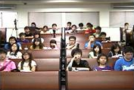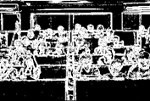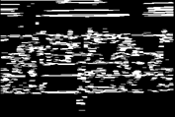
    - (b) (c)
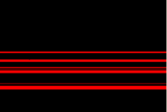
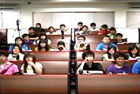
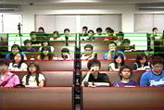

(d) (e) (f)
Figure 4. An example of the main line location process.

Figure2 shows the flowchart of the main line location process, and Figure4 shows an example. Once the video sequence frames have been inputted into the system, the system detects the edges using Sobel‟s approach. Figure 3(a) shows one of the input frames, and the edge detection result is shown in Figure 3(b). Subsequently, the system extracts the horizontal edges by implementing the morphological opening operation, using a 5X1 horizontal kernel, and is shown in Figure 3(c). The horizontal edges are projected in the horizontal direction to obtain the numbers of the edge pixels, which can be regarded as the importance of the main line edges.
The system can extract the main line candidates from the bottom of the frame based on the degree of importance. The red lines shown in Figure 3(d) indicate the main line candidates. The system clusters these candidates into different classes and calculates the average locations of these classes to identify the real positions of the main lines. Only three main lines located in the bottom of the frame are extracted and preserved for the following process, as depicted in Figure 3(e). Finally, the system will calculate the locations of the other main lines using a geometric series, as depicted by the green lines shown in Figure 3(f).

The system can detect motion by subtracting the intensity values of the pixels in the tth frame from the corresponding pixels in the t-1th frame and by calculating the absolute values of the subtraction results. Let the intensity values of a pixel p at time t-1 and t be I_{t-1}(p) and I_{t}(p), respectively. Therefore, the magnitude of the motion of this pixel can be defined as

M ( p) =| It ( p) − It−1( p) |

Foreground Pixel Extraction and Identification

Moreover, the translation equation to calculate the Cr value of the pixel in the YCrCb model is given by:

Cr = (0.500)Rp + (−0.4187)Gp + (−0.0813)B

Based on these two components, the system first accumulates the pixel numbers from the input frame to form a histogram of the hue and Cr values . Figure 6 (c) shows the Hue-Cr histogram of the image in Figure 6 (a). It is assumed that the background occupies larger regions than the foreground in the home. Therefore, the system normalizes and sorts these pixel numbers on the histogram. After normalization, the top 40% of pixels are classified as the background pixels, and the bottom 5% pixels are classified as the candidates of the foreground pixels.
Subsequently, the system identifies the foreground pixels using motion, color, and template information. Given a pixel p, let M(p) indicate the normalized.

Object Segmentation

The system segments the objects by the process of region combination. Using a graph to represent an object, each region can be regarded as a node of the graph. If two regions are next to each other, then a link will be added to connect these two corresponding nodes in the graph. The weight of this link represents the strength of the connection between these two nodes. Let the two nodes be denoted by n_{k} and n’_{k} respectively. The weight of the link can be defined as

w(n , n' ) = max( A(nk ), A(n'k )) k k 2L

Gesture Recognition

The system divides members gestures into six classes, which include raising the left hand, raising the right hand, raising two hands, standing up, lying prone, and normal posture. Figure 10 illustrates some examples of these six classes, which can be regarded as states and be constructed to form a finite state machine. We assume that the initial state of the finite automaton is the normal posture.Here, a ^{t}, p ^{t}, and m^{t} indicate the area, the center position, and the motion of the object at frame t, respectively. Symbols d ^{t}, g ^{t}, and c ^{t} are vectors which indicate theareas, the center positions, and the colors of the regions belonging to object i, respectively. A change in these feature values at successive frames can translate the finite automaton from one state to another. Thus, we define 14 rules (corresponding to transitions a to l) to translate the states. For example, if the center positions of some left regions of object i move upwards and are larger than a preset threshold value, and the area and center position of object i increase, then the members may be raising his/her left hand. This situation can cause a state transition from normal‟ to „raising the left hand‟ through transition a

Experimental Results
The input sequences for our system were acquired using a PTZ camera mounted on a platform and processed on a PC with an IntelRCore™ 2.186GHz CPU. The PTZ camera is set at a height of approximately 155 cm to 175 cm above the floor. The input video sequences are recorded at a rate of 30 frames/second.
Figure 11 shows an example of the members is raising her hand. The first column illustrates three selected frames of this sequence, and the second column shows their corresponding region growing results. Their segmentation results are shown in the third column. In this case the state of the finite state machine will change from „normal‟ to „raising the right hand‟ through transition b.

l = []
list_names = []
for i in range(10):
l.append(0)
for i in range(len(x)):
if(l[y[i] - 1] == 0):
l[y[i] - 1] = i
if(len(np.unique(l)) == 10):
break
for i in range(len(l)):
%matplotlib inline
print("Class Label: " + str(i + 1))
plt.imshow(np.asarray(z[l[i]]), cmap =cm.gray)
plt.show()
plt.imshow(np.asarray(x[l[i]]), cmap = cm.gray)
plt.show()

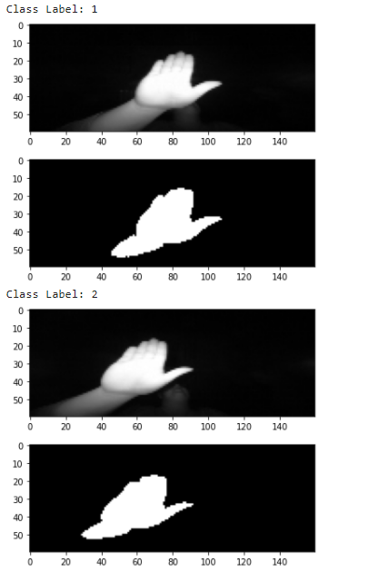
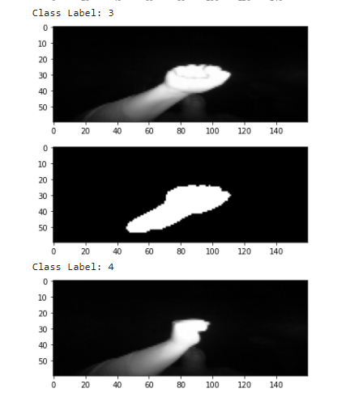

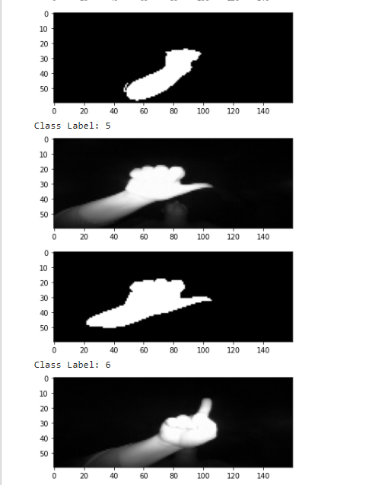
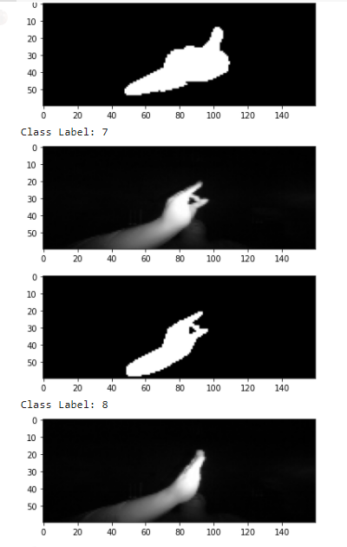

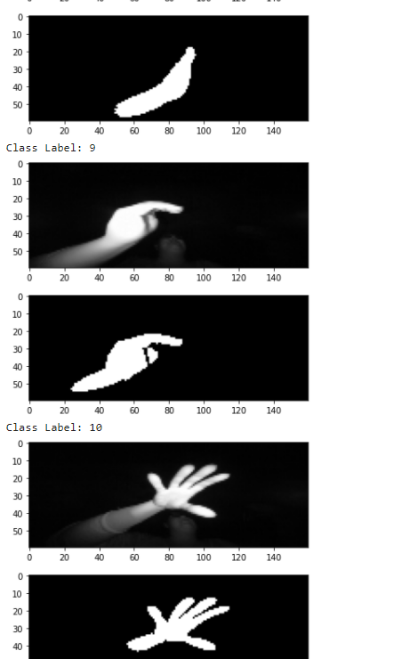

Code to check accuracy:

model.compile(optimizer='rmsprop',
loss='categorical_crossentropy',
metrics=['accuracy'])
history = model.fit(x_train, y_train, epochs=10, batch_size=64, verbose=1, validation_data=(x_validate, y_validate))

Output:

Epoch 1/10 250/250 [==============================] - 68s 211ms/step - loss: 0.8943 - accuracy: 0.6977 - val_loss: 0.0121 - val_accuracy: 0.9985
Epoch 2/10 250/250 [==============================] - 52s 208ms/step - loss: 0.0294 - accuracy: 0.9929 - val_loss: 0.0941 - val_accuracy: 0.9765
Epoch 3/10 250/250 [==============================] - 52s 207ms/step - loss: 0.0093 - accuracy: 0.9980 - val_loss: 0.0053 - val_accuracy: 0.9990
Epoch 4/10 250/250 [==============================] - 53s 211ms/step - loss: 0.0159 - accuracy: 0.9968 - val_loss: 0.0144 - val_accuracy: 0.9980
Epoch 5/10 250/250 [==============================] - 52s 208ms/step - loss: 0.0051 - accuracy: 0.9989 - val_loss: 0.0011 - val_accuracy: 0.9990
Epoch 6/10 250/250 [==============================] - 52s 208ms/step - loss: 0.0054 - accuracy: 0.9992 - val_loss: 0.0061 - val_accuracy: 0.9980
Epoch 7/10 250/250 [==============================] - 52s 209ms/step - loss: 3.8567e-04 - accuracy: 0.9999 - val_loss: 0.0116 - val_accuracy: 0.9990
Epoch 8/10 250/250 [==============================] - 52s 209ms/step - loss: 0.0019 - accuracy: 0.9996 - val_loss: 0.0120 - val_accuracy: 0.9990
Epoch 9/10 250/250 [==============================] - 52s 208ms/step - loss: 0.0022 - accuracy: 0.9992 - val_loss: 0.0063 - val_accuracy: 0.9990
Epoch 10/10 250/250 [==============================] - 52s 208ms/step - loss: 0.0023 - accuracy: 0.9995 - val_loss: 0.0116 - val_accuracy: 0.9990

acc = history.history['accuracy']
val_acc = history.history['val_accuracy']

loss = history.history['loss']
val_loss = history.history['val_loss']

epochs_range = range(10)

plt.figure(figsize=(8, 8))
plt.subplot(1, 2, 1)
plt.plot(epochs_range, acc, label='Training Accuracy')
plt.plot(epochs_range, val_acc, label='Validation Accuracy')
plt.legend(loc='lower right')
plt.title('Training and Validation Accuracy')

plt.subplot(1, 2, 2)
plt.plot(epochs_range, loss, label='Training Loss')
plt.plot(epochs_range, val_loss, label='Validation Loss')
plt.legend(loc='upper right')
plt.title('Training and Validation Loss')
plt.show()

GRAPH:
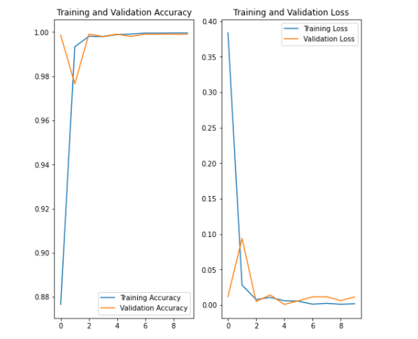

Conclusion with future enhancements
In this paper, we proposed a home automation based members gesture analysis system. The system first locates the main line and identifies the foreground pixels. Using the technique of region growing, the member can be segmented. Then, a finite state machine is used to recognize various members gestures. Currently, the accuracy rate of the proposed system is 72%. We believe that the accuracy rate can be increased with the incorporation of some prior knowledge into the system.
This is a new attempt to apply image processing techniques to help the teacher to notice some behaviours of the member in home. We hope the system can be improved and practiced in the future. Moreover, since more than one members may change their gestures at the same time, using multiple PTZ cameras to detect multiple members gestures simultaneously may be a good area of research for the future.

- References:
- https://www.engineersgarage.com/electronic-projects/gesture-based-home-automation-system/

- http://www.instructables.com/id/Gesture-Based-Home-Automation-Using-Intel-EdisonIn/

- Digital image processing (fourth edition) by Raphael C.Gonzalez, Richard E. Woods

- Feature extraction & Image Processing for computer vision (third edition) by Mark S. Nixon and Alberto S. Aguado

- Introduction to Biometrics by Anil K. Jain, Arun A. Ross, Karthik Nandakumar

